Gralee School Newsletter
Today for Tomorrow

Find us at: Yanco Ave Leeton PH: 6953 3350 Fax: 6953 5192 Email: gralee-s.school@det.nsw.edu.au
Week 6 Term 1, 2019 | 08/03/2019

Principal’s notes

- Swimming at the Griffith Aquatic Centre commenced on Wednesday, 6th March for all students and will continue for all students this term
- Work to commence on the shade structure for the trampoline area on Monday, March 11th.
- Three new slimline interactive screens were installed on Wednesday March 6^{th.}
Review Meetings:
March 18th- Monday
March 19th- Tuesday
PLEASE note:
The following will apply-
Star class parents and students on the Monday
Gold class Tuesday morning
Diamond class- Tuesday after 12.45pm
SCHEDULES went home on Thursday (yesterday)
Birthdays
Someone is turning 18 on the 16th of March….I wonder who it is?

Could the person be Bryce???????
School Canteen
WEEK | Meals are all $5 and are served with a drink.
7 | Prawn, Pea and Fetta Salad
8 | Fish Fingers and Chips
9 | Curried Sausages with Mashed Vegies.
10 | P&C LUNCH
 | Orders are to be in on a WEDNESDAY
HOME READING PROGRAM recommenced this year.
P&C
Next meeting: 14th March
You are all welcome to come along

SRC WHAT’S ON:
Work experience is underway for Deon, Pieper and Amy: each Thursday they travel to Narrandera to engage with the linen service.
For Connor and Bryce, work experience is at IGA from 9.30am to 11am each Thursday with Natasha. They are currently working in the aisles stacking the shelves.
Jake has commenced integration at Leeton High School also on a Thursday. Natasha and Mr.H accompany Jake to engage with a Year 10 group from 12.55 to 1.30pm.
Bryce will be at the Bidgee Classic selling hotdogs this weekend along with a few staff members and parents.
The staff members have enrolled to participate in a Walk for Autism week later this month. They are seeking sponsorship to walk 10000 steps per day for a week. If you want to sponsor a staff member just ring the school.

STAR class have a secret surprise for the birthday boy on Thursday!

Today, Connor and Bryce were busy cooking onion and bacon in preparation for the Bidgee Classic
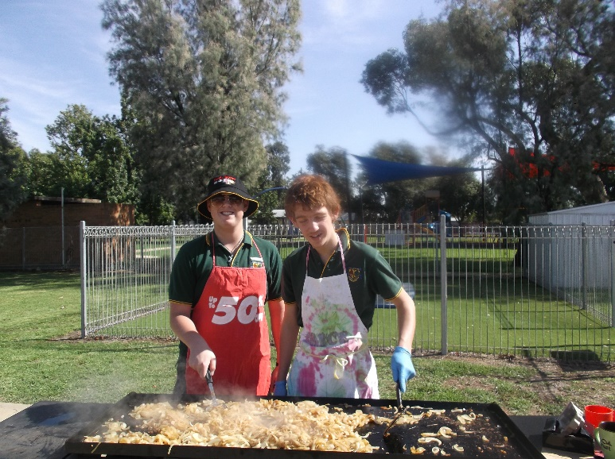

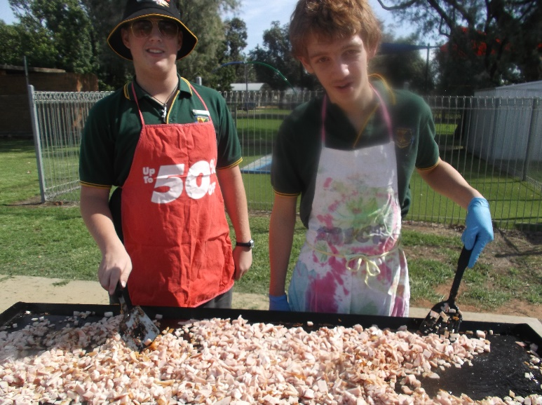
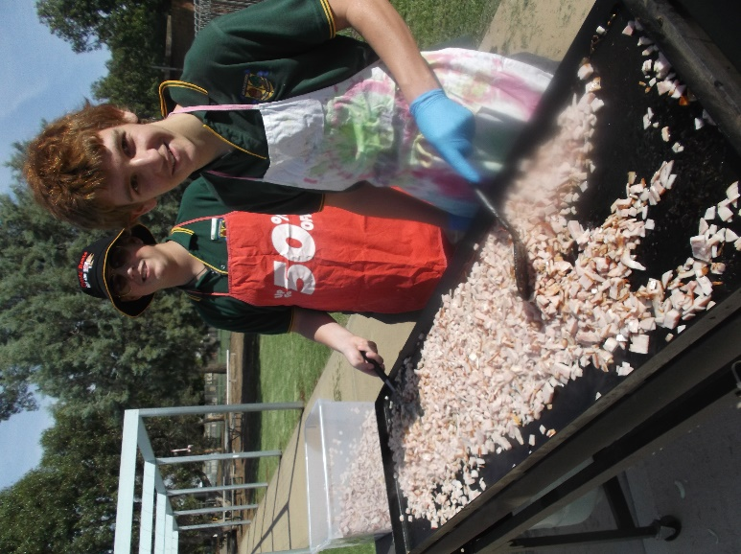

UPCOMING EVENTS
Celi Group Charity Day- golf day:
7th April
More information after the P&C meeting.
We are hoping for all parents to assist on the day in some capacity.
After the P&C meeting this Thursday, the school will send home a roster requesting support for this major fund-raising event
Harmony Day BRUNCH on Wednesday, 20th March from 8.00am to 10am
Weekly AWARDS
WEEK 5
Gold Class: Isabella Bull, Mason Watts
Star Class: Deon Henry and Pieper Hawkins for engaging with work-experience
Diamond Class: Emma Preston
Principal’s Award: Dakota Hawkins
Staff member award: Heidi- liaison with NDIS providers
Bus Drivers’ Award: Pieper Hawkins
SunSmart award: Connor Mackay- wearing his hat
Swimmer of the Week: Deon Henry- for somebody who, until recently, declared that she was not a swimmer!

WELL-BEING

The ideals which have lighted my way, and time after time have given me new courage to face life cheerfully, have been kindness, beauty and truth.
Albert Einstein
Attachments:
- Book Club

